**TOTE SEAL**

**Designed Specifically for Totes**



The Tote Seal is a fixed-length security seal designed specifically to secure tote boxes used to

transport merchandise from one location to another. Because totes require two seals to be

properly secured, the Tote Seal is always manufactured in “twin” sets with identical numbers.

Features:

• Durable, all plastic, one-piece construction.

• Patented, tamper-resistant locking mechanism and design.

• Thin, flat sealing strap designed to fit most totes; available in 2 lengths.

• Identically numbered and hot stamped with a company name or logo.

Seals shown not actual size.

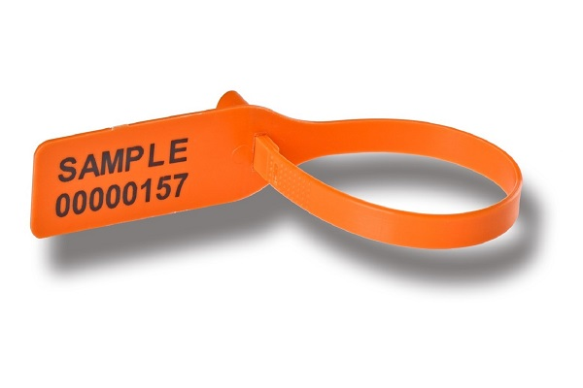

Applications:

• Tote Boxes

• In-flight Service Carts

• Storage Equipment

• Trailers w/multiple doors



All Dimensions are in mm.

Materials: Polypropylene Hot Stamped Printing:

Numbering: 8 digits

Overall length: 5” and 7” Name/Logo: 1” x .25”

Operational length: Packing: 7” seal: 1,000 seals per carton

7” seal: 4.965” 11” seal: 1,000 seals per carton

11” seal: 9.087”

Gross Weight:

Diameter when locked: 7” seal: 8 lbs. per carton

7” seal: 1” 11” seal: 10 lbs. per carton

11” seal: 1.5625”

Box Dimensions:

Breakstrength: 7” seal: 9.4” x 8.3” x 17.7”

44 lbs. 11” seal: 9.4” x 12.2” x 17.7”

